**NOTE:**

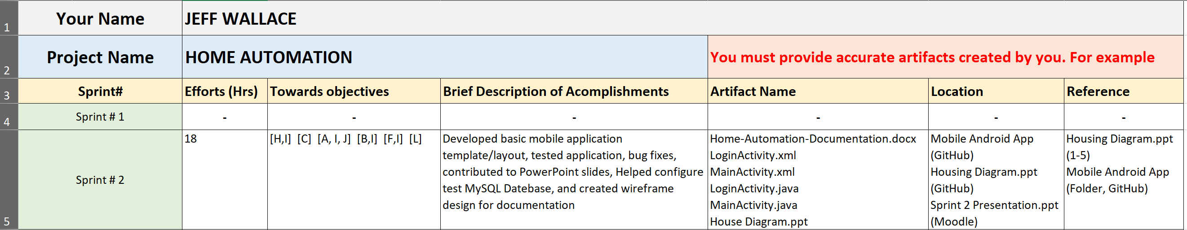See “HousingApp” folder in our GitHub’s master branch for my code commits. Reference my efforts log to see what I have contributed. All my code was pushed from Jheryl’s branch. Thanks.